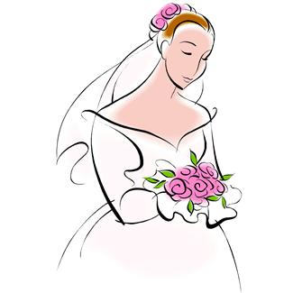

I am the Father of the Bride.

I watched my daughter learn to walk and ride a bicycle. I bandaged scraped knees and let her cry on my shoulder when she was hurt. When she learned how to drive, I sat in the passenger seat while she drove around the county.

It was my responsibility to provide all that she needed. As I walk her down the aisle today, I will turn that job over to someone else. I am not losing my daughter today, but gaining a new member of my family.

Please pray with me that they will have a happy and joyous life together.



I am the Father of the Bride.

I watched my daughter learn to walk and ride a bicycle. I bandaged scraped knees and let her cry on my shoulder when she was hurt. When she learned how to drive, I sat in the passenger seat while she drove around the county.

It was my responsibility to provide all that she needed. As I walk her down the aisle today, I will turn that job over to someone else. I am not losing my daughter today, but gaining a new member of my family.

Please pray with me that they will have a happy and joyous life together.



I am the Father of the Bride.

I watched my daughter learn to walk and ride a bicycle. I bandaged scraped knees and let her cry on my shoulder when she was hurt. When she learned how to drive, I sat in the passenger seat while she drove around the county.

It was my responsibility to provide all that she needed. As I walk her down the aisle today, I will turn that job over to someone else. I am not losing my daughter today, but gaining a new member of my family.

Please pray with me that they will have a happy and joyous life together.



I am the Father of the Bride.

I watched my daughter learn to walk and ride a bicycle. I bandaged scraped knees and let her cry on my shoulder when she was hurt. When she learned how to drive, I sat in the passenger seat while she drove around the county.

It was my responsibility to provide all that she needed. As I walk her down the aisle today, I will turn that job over to someone else. I am not losing my daughter today, but gaining a new member of my family.

Please pray with me that they will have a happy and joyous life together.



I am the Father of the Bride.

I watched my daughter learn to walk and ride a bicycle. I bandaged scraped knees and let her cry on my shoulder when she was hurt. When she learned how to drive, I sat in the passenger seat while she drove around the county.

It was my responsibility to provide all that she needed. As I walk her down the aisle today, I will turn that job over to someone else. I am not losing my daughter today, but gaining a new member of my family.

Please pray with me that they will have a happy and joyous life together.



I am the Father of the Bride.

I watched my daughter learn to walk and ride a bicycle. I bandaged scraped knees and let her cry on my shoulder when she was hurt. When she learned how to drive, I sat in the passenger seat while she drove around the county.

It was my responsibility to provide all that she needed. As I walk her down the aisle today, I will turn that job over to someone else. I am not losing my daughter today, but gaining a new member of my family.

Please pray with me that they will have a happy and joyous life together.

Courtesy of Amelia Rhodes [www.ameliarhodes.com](http://www.ameliarhodes.com) as seen in *Chicken Soup for the Soul: Here Comes the Bride*